**DAILY ONLINE ACTIVITIES SUMMARY**

|  |  |  |  |  |  |  |  |
| --- | --- | --- | --- | --- | --- | --- | --- |
| **Date:** | **08/06/2020** | | | | **Name:** | **Anusha. K** | |
| **Sem & Sec** | **4th SEM 'A' Section** | | | | **USN:** | **4AL18CS009** | |
| **Online Test Summary** | | | | | | | |
| **Subject** | | **Transform calculus, probability and statistical methods** | | | | | |
| **Max. Marks** | | **30** | | **Score** | | **16** | |
| **Certification Course Summary** | | | | | | | |
| **Course** | **Introduction to Hadoop** | | | | | | |
| **Certificate Provider** | | | **greatlearning academy** | **Duration** | | | **4 hours** |
| **Coding Challenges** | | | | | | | |
| **Problem statement 1:**  C Program to Generate All the Set Partitions of n Numbers Beginning from 1 and so on.  **Problem statement 2:Write a Java Program to check whether the given matrix is magic square or not** | | | | | | | |
| **Status: completed** | | | | | | | |
| **Uploaded the report in Github** | | | | **yes** | | | |
| **If yes Repository name** | | | | [**https://github.com/anusha20219/Lockdown-coding**](https://github.com/anusha20219/Lockdown-coding) | | | |
| **Uploaded the report in slack** | | | | **yes** | | | |

ONLINE TEST DETAILS: maths test was conducted from 9.30 am to 10.10 am. There were 15 questions and time assigned was 40 minutes. The questions were mcq type. The portion was module 2.

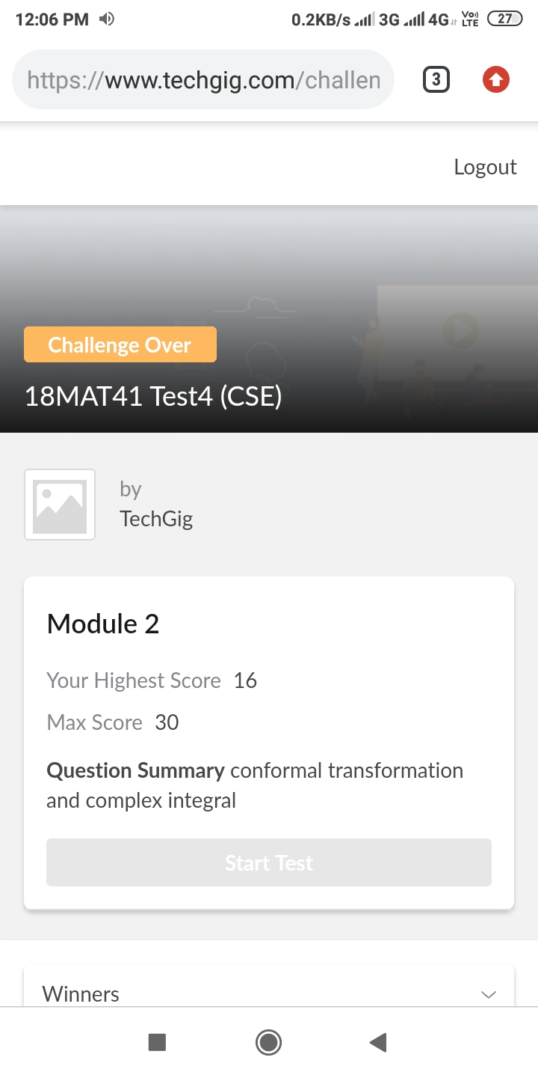CERTIFICATION COURSE DETAILS: Today I completed introduction to full stack development and then started with introduction to hadoop where I studied about big data, ETL,hadoop and distributed computing.



**Coding challenge details:**

**Problem statement:1**

**C Program to Generate All the Set Partitions of n Numbers Beginning from 1 and so on.**

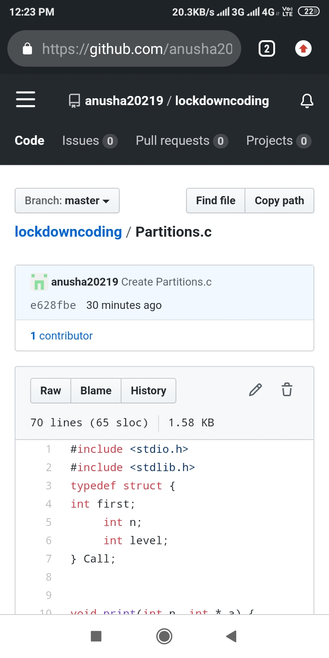

**Problem statement:2**

**Write a Java Program to check whether the given matrix is magic square or not.**

